The University of Iowa Quarknet Teacher Institute
July 9 – 13, 2018
The following 20 teacher participants joined our summer-long student researchers at The University of Iowa for a week-long teacher institute:
Peter Bruecken | Mike Grannon | Joshua Hoffman | Diane May | David Sattgast
Joe Culwell | Geralyn Harnisch | Sue Jarvis | Kala Miller | Jamey Smith
Terry Frisch | James Herzog | Chris Like | Mark Nail | Ian Spangler
Duane Garien | Bob Hesman | Erik Malvik | Tricia Reichert | Amy Tursi

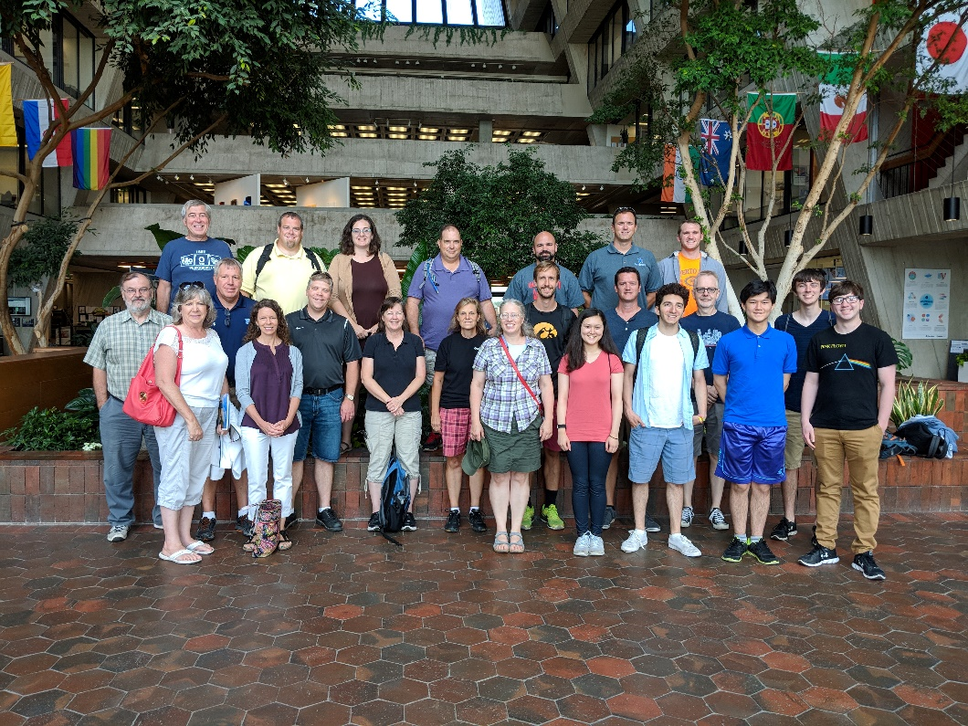
The following photo of these teachers, along with the student research group, was taken during our Fermilab tour on Wednesday, July 11, 2018:
During the week, the teachers participated in an interactive group of activities that involved:
- a 2-day CMS E-lab, a tour of Fermilab
- a talk on the Large Hadron Collider at CERN
- a display of physics demonstrations
- a guest speaker from the Science Education Department
- an interactive activity on the particle-wave duality of light.
Central to the institute was the implementation of the new Iowa Science Standards. Teachers focused on implementing these standards in their curricula and refined methods to teach these standards while using the ideas of particle physics.

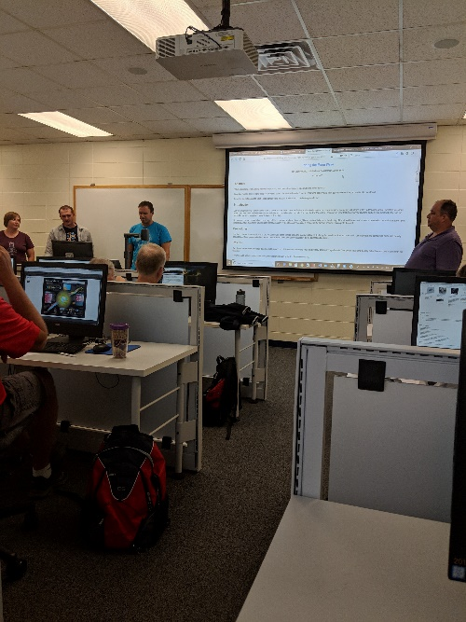
CMS E-Lab:
Marla Glover from Quarknet visited us at The University of Iowa and directed a 2-day CMS E-lab for our participants. During the lab, teachers downloaded data from CMS and did analysis using the Quarknet online tools. The teachers made reports on the analysis of their data and presented it to each other in groups. The teachers discussed how to make lesson plans and assessments from these tools and align them with the new Iowa Science Standards. The teachers found the E-lab materials very useful for the design of curriculum that aligned with the new teaching standards.
The teachers concluded that the use of the real-world data from CMS related well with standards directed at analysis. Standards are often not content specific and using Large Hadron Collider data brought relevance to these activites. Students could tap into the rather abstract concept of CERN and see how data is used to make conclusions. This mates very well with the new science standards

Tour of Fermilab:
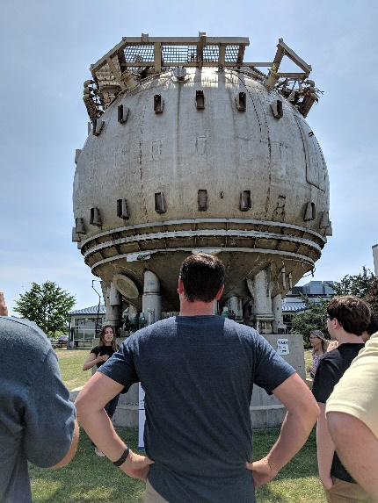
On Wednesday, July 11, 2018 our research student team joined our teachers for a tour of Fermilab. Our tour included the general tour of Wilson Hall, the accelerator, the bubble chamber of the past and a special tour of the CCD detectors at the South Pole. Our teachers experienced the history of particle physics from the days of old where photographs of hydrogen bubble tracks contained the data to the new acquisition techniques where computers collect and analyze data. This highlighted the growth of new technologies and their implementation into our daily lives. The heritage hydrogen bubble could never be used to acquire dark energy data at the South Pole yet the functions of the bubble and places like Fermilab are parallel.
Teache Presentations 1

While at Fermilab, we attended a seminar with a scientist where we spent time interacting with one of Fermilab’s investigators. Teachers really enjoyed relating to the different life style of a person dedicated to researching science. They commented on how they are better equipped to represent science careers to their students.
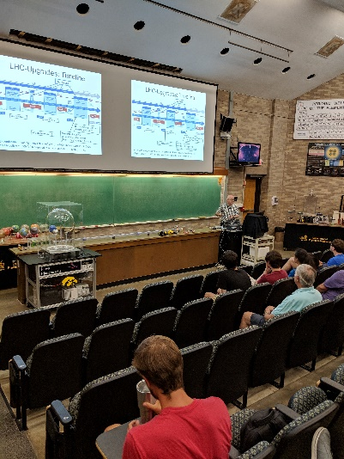

Dr. Onel’s CMS Talk:
The teachers attended a lecture by our principle investigator, Dr. Yasar Onel, head of the CMS group at The University of Iowa. Dr. Onel gave an update on the most recent outcomes of research at CMS. Much of the focus was on the search for the Higgs Boson. Dr. Onel highlighted the collaboration between the two detectors, CMS and Atlas, in the discovery of the Higgs. The train of thought from the data to conclusion made clear the complexity of the CMS detector and how the conclusions in particle physics are supported by a complicated stream of data. His presentation encompassed the overall design of The LHC all the way down to specific plots that indicated the presence of the products of the Higgs.

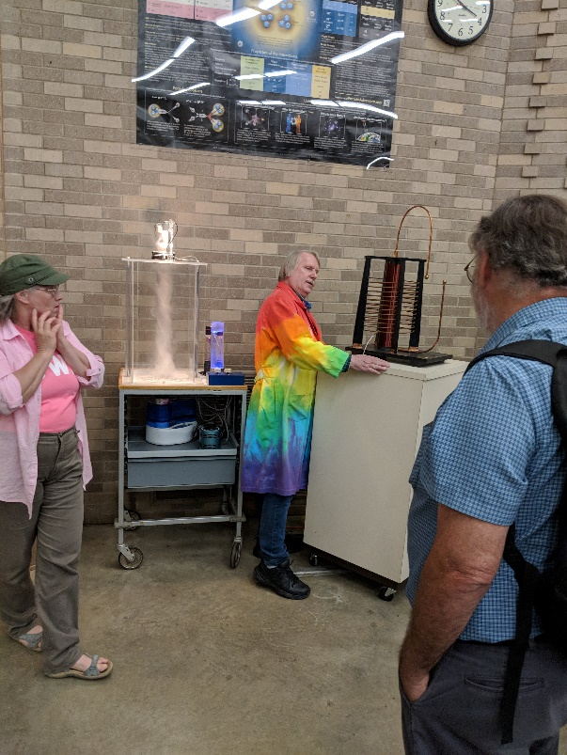
Physics Demonstrations:
Dale Stille, the resident physics demonstration expert, presented the group with a vast array of current physics demonstrations. Dale invited teachers to ask questions and even gave away some equipment to those interested in expanding their own physics demonstrations.
Dale tailored his presentation around demonstrations of phenomena in the new science standards and refinements on older demonstrations. He also showed how to use readily available equipment demonstrate some complex concepts and how to obtain equipment for their own use.

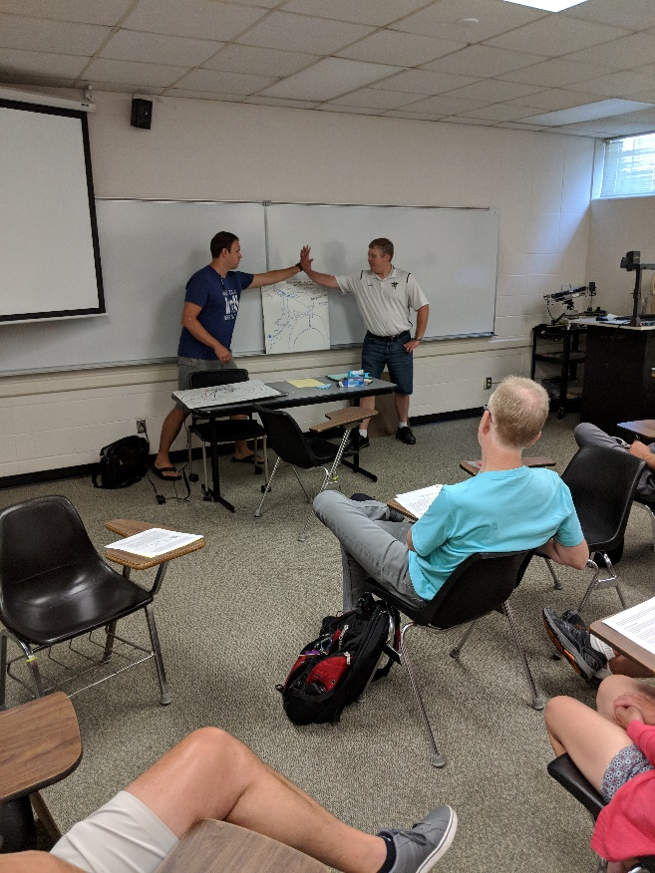

Science Education Guest:
Dr. Mark McDermott from the University Of Iowa Science Education Department presented to our group on the organization and effective implementation of the new Iowa Science Standards in science classrooms. The group found the explanations helpful in using some of the information and strategies that were experienced during the previous week.
Our participants designed and presented a unit on The Wave-Particle duality of light. They each had a historic discovery or investigation that led to our current ideas and presented them as a unit to each other. The teachers saw how students can follow the standards using their own presentations to build ideas and how that mirrors real life.

